**EXPERIMENT 2.2**

**NAME: Yash Gupta UID: 20BCS5009**

**SECTION: 709 “A” Sub: Software Engineering**

**AIM:**

Draw a use case Diagram.

**Task to be done:**

Design a use case diagram for airport check-in and security screening.

**Summary**: Business use cases are Individual Check-In, Group Check-In (for groups of tourists), Security Screening, etc. - representing business functions or processes taking place in an airport and serving needs of passengers.

[**Bank ATM UML use case diagrams examples**](https://www.uml-diagrams.org/bank-atm-uml-use-case-diagram-example.html?context=uc-examples)

**Purpose**: Describe use cases that an automated teller machine (ATM) or the automatic banking machine (ABM) provides to the bank customers.

**Summary**: Customer uses a bank ATM to check balances of his/her bank accounts, deposit funds, withdraw cash and/or transfer funds (use cases). ATM Technician provides maintenance and repairs to the ATM.

**Requirement Analysis:**

* **Software Requirement:** 
  1. Creately
  2. Google Chrome
* **Hardware Requirement:** 
  1. Computer
  2. Windows 10+ **3.** Power Supply

**Use Case Diagram for Airport:**

Use Case Diagram captures the system’s functionality and requirements by using actors and use cases. Use Cases model the services, tasks, function that a system needs to perform. Use cases represent high-level functionalities and how a user will handle the system. Use-cases are the core concepts of Unified Modelling language modeling.

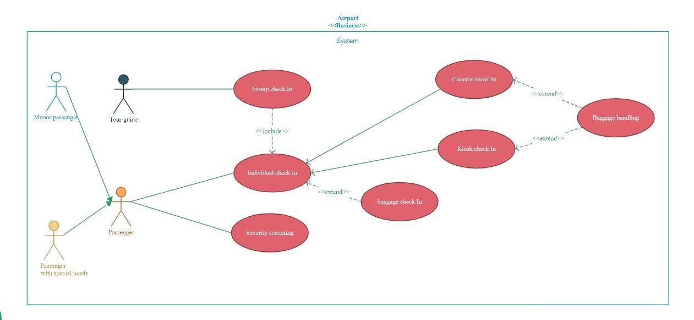

**Use Case Diagram for ATM:**

Use Case Diagram captures the system’s functionality and requirements by using actors and use cases. Use Cases model the services, tasks, function that a system needs to perform. Use cases represent high-level functionalities and how a user will handle the system. Use-cases are the core concepts of Unified Modelling language modeling.

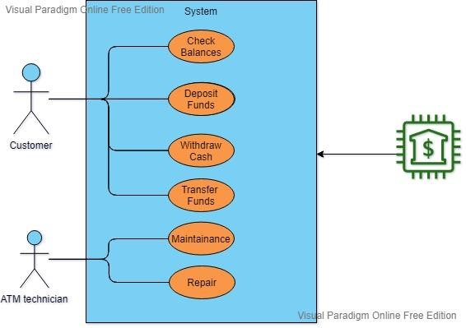

**Evaluation Grid (To be created as per the SOP and Assessment guidelines by the faculty):**

|  |  |  |  |
| --- | --- | --- | --- |
| Sr.  No. | Parameters | Marks Obtained | Maximum Marks |
| 1. |  |  |  |
| 2. |  |  |  |
| 3. |  |  |  |
|  |  |  |  |

# CHANDIGARH UNIVERSITY SOFTWARE ENGINEERING LAB